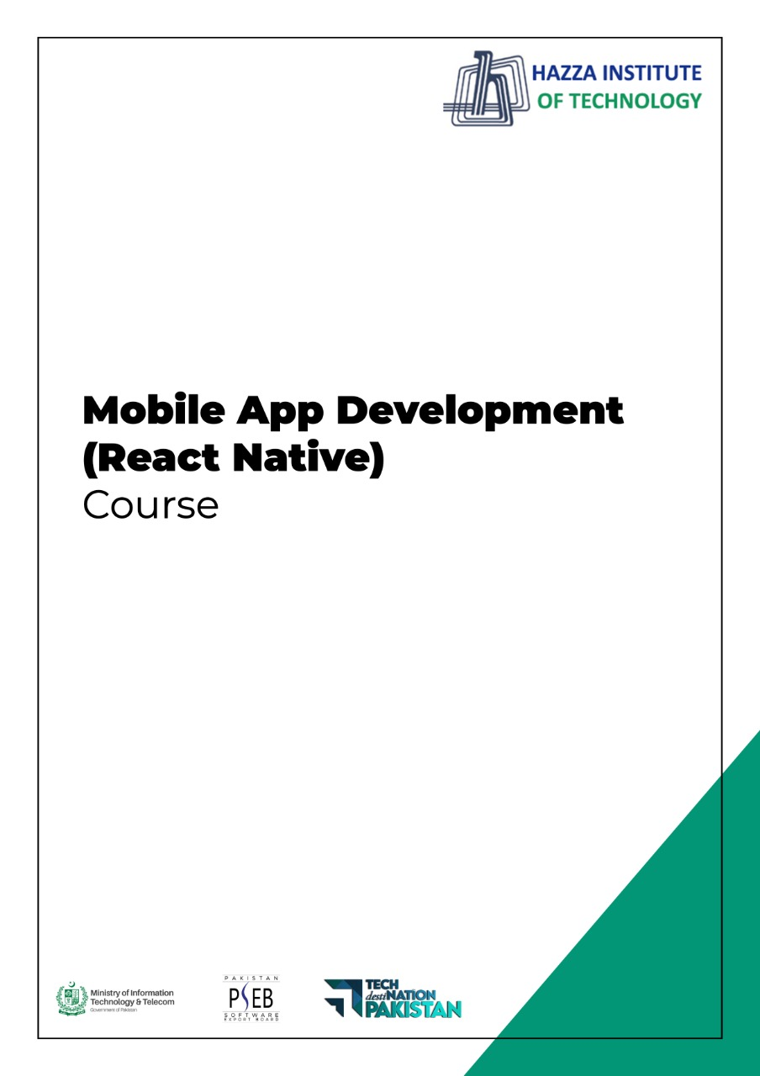
(Flutter: Dart)
Lab 2 (Session 2)

Total Time:
3 hours (sessions-2)

Pre-Lab Activities:
  - Familiar with dartpad for dart Editor
  - Student must complete Lab-2 session-1 before attempting these labs.

Learning Outcomes:
  - Demonstrate the knowledge of Dart OOP.

Student Activities:
  - Open Dartpad, and do advance exercise for dart

Lab Tasks 1:
Make a two-player Rock-Paper-Scissors game against computer.
Ask for player’s input, compare them, print out a message to the winner.

Lab Tasks 2:
Generate a random number between 1 and 100. Ask the user to guess the number, then tell them whether they guessed too low, too high, or exactly right.

Lab Tasks 3:
Ask the user for a number and determine whether the number is prime or not.
Do it using a function

Lab Tasks 4:
Write a program (function) that takes a list and returns a new list that contains all the elements of the first list minus all the duplicates

Lab Tasks 5:
Write a program (using functions!) that asks the user for a long string containing multiple words. Print back to the user the same string, except with the words in backwards order.
For example, say I type the string:
My name is Michele
Then I would see the string:
Michele is name My

Lab Solutions:

LAB 2.1 :
import 'dart:io';
import 'dart:math';

void main() {
print("Welcome to Rock, Paper, Scissors\nType 'exit' to stop the game");
final random = Random();

// Rules of the game
Map<String, String> rules = {
"rock": "scissors",
"scissors": "paper",
"paper": "rock"
};

// Initial score
int user = 0;
int comp = 0;

// Options for computer to choose
List<String> options = ["rock", "paper", "scissors"];

// Actual game
while (true) {
String compChoice = options[random.nextInt(options.length)];
stdout.write("\nPlease choose Rock, Paper or Scissors: ");
String userChoice = stdin.readLineSync().toLowerCase();

if (userChoice == "exit") {
print("\nYou: $user Computer: $comp\nBye Bye!");
break;
}

if (!options.contains(userChoice)) {
print("Incorrect choice");
continue;
} else if (compChoice == userChoice) {
print("We have a tie!");
} else if (rules[compChoice] == userChoice) {
print("Computer wins: $compChoice vs $userChoice");
comp += 1;
} else if (rules[userChoice] == compChoice) {
print("You win: $userChoice vs $compChoice");
user += 1;
}
}
}

LAB 2.2 :
import 'dart:io';
import 'dart:math';

void main() {
print("Type exit to quit the game");
guessingGame();
}

guessingGame() {
final random = Random();
int randNumber = random.nextInt(100);
int attempt = 0;

while (true) {
attempt += 1;
stdout.write("Please choose a number between 0 and 100: ");
String chosenNumber = stdin.readLineSync();

// Make sure user does not go out of limits
if (chosenNumber.toLowerCase() == "exit") {
print("\nBye");
break;
} else if (int.parse(chosenNumber) > 100) {
print("Please do not go over 100");
continue;
}

// Main logic
if (int.parse(chosenNumber) == randNumber) {
print("Bingo! You tried $attempt times\n");
continue;
} else if (int.parse(chosenNumber) > randNumber) {
print("You are higher");
continue;
} else {
print("You are lower");
continue;
}
}
}

LAB 2.3 :
import 'dart:io';

void main() {
stdout.write("Please give us a number: ");
int chosenNumber = int.parse(stdin.readLineSync());

checkPrime(chosenNumber);
}

void checkPrime(int number) {
// List comprehensions
List<int> a = [
for (var i = 1; i <= number; i++)
if (number % i == 0) i
];

// Check for prime
a.length == 2
? print("The chosen number is a prime")
: print("The chosen number is not a prime");
}

LAB 2.4 :
import 'dart:math';

void main() {
final random = Random();
List<int> randList = List.generate(10, (_) => random.nextInt(10));

print("Initial list is $randList\n");
print("Cleaned list is ${removeDuplicates(randList)}");
}

List<int> removeDuplicates(List<int> initialList) {
return initialList.toSet().toList();
}

LAB 2.5 :
import 'dart:io';

void main() {
stdout.write("Please give a sentence: ");
String sentence = stdin.readLineSync();

reverseSentence(sentence);
}

void reverseSentence(String sentence) {
/* Split the sentence into a list of words
Reverse the list, then join the words back */
String a = sentence.split(" ").reversed.toList().join(" ");
print(a);
}

